

November 2017

**“Identifying Interstitial Lung Diseases”**

**PROJECT REPORT**

Submitted for CAL in B.Tech Image Processing (CSE4019)

By

**Puneet Jain**

**(15BCE1351)**

**Name of faculty: Asnathvicty Phamilay**

**(SCHOOL OF COMPUTER SCIENCE)**

**CERTIFICATE**

This is to certify that the Project work entitled “**Identifying Interstitial Lung Diseases**” that is being submitted by “***Puneet Jain***” for CAL in B.Tech Image Processing (CSE4019) is a record of bonafide work done under my supervision. The contents of this Project work have not been submitted for any other CAL course.

Place: Chennai

Date: 10/11/2017

**Signature of Student**:

**Signature of Faculty:**

**ACKNOWLEDGEMENTS**

We thank VIT University (**SCHOOL OF COMPUTER SCIENCE**) for giving us the opportunity to conduct this project and experiment. We also thank our guide for project. Prof. Asnathvicty Phamilay for her constant, good and knowledgeable guidance for the project. Through this project, we learned many of new things about the way Human and Computer interact in Image Processing.

HARENDRA SINGH

Reg. No. 15BCE1117

PUNEET JAIN

Reg. No. 15BCE1351

**ABSTRACT**

**Project Name: Identifying Interstitial Lung Diseases**

This is project about identifying interstitial lungs disease using image processing techniques that identifies the lung diseases in the given input image and retrieves a similar image, using image feature similarity.

**1. Introduction:**

To design a system that retrieves similar images using the image features such as the Gabor Wavelet and Discrete Wavelet transform. The system is basically built for identifying lung diseases using the CT scans of the lungs, the existing CT scan images of the diseases are taken into the database and the feature extraction process is done upon them the values are stored in a matrix and then in the end these values of database images are compared with the query image and by using the similarity metric (manhattan distance), the most relative image is retrieved.

**2. Methodology:**

Image Feature An image texture is a set of metrics calculated in image processing designed to quantify the perceived texture of an image. Image texture gives us information about the spatial arrangement of color or intensities in an image or selected region of an image.

Image textures can be artificially created or found in natural scenes captured in an image. Image textures are one way that can be used to help in segmentation or classification of images.

**Gabor Feature**

In image processing It is a linear filter used for texture analysis, which means that it basically analyses whether there are any specific frequency content in the image in specific directions in a localized region around the point or region of analysis. Frequency and orientation representations of Gabor filters are similar to those of the human visual system, and they have been found to be particularly appropriate for texture representation and discrimination.

Code Snippet

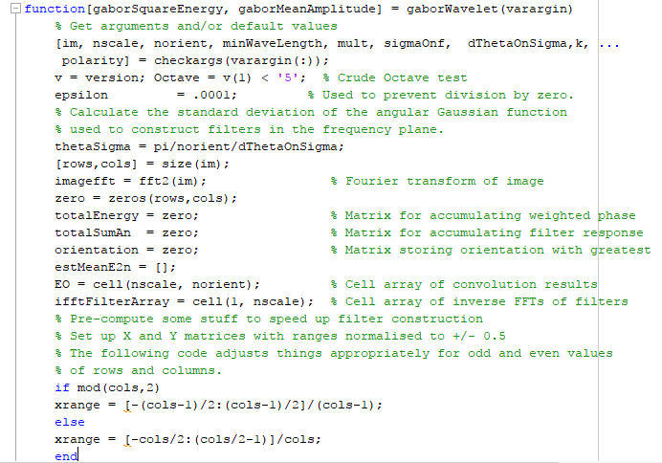

**Discrete Wavelet Transform**

Wavelets are often used to denoise two dimensional signals, such as images. The following example provides three steps to remove unwanted white Gaussian noise from the noisy image shown. Matlab was used to import and filter the image.

The first step is to choose a wavelet type, and a level N of decomposition.

Code Snippet

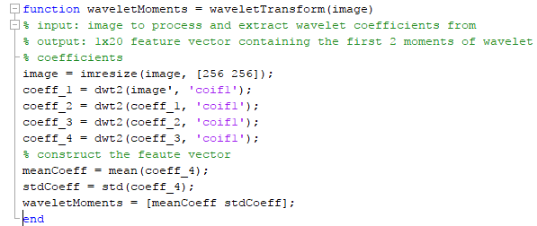

**Processing**

The image to be processed or the CT scan that needs to be checked is given as the query image and then it is processed in the Matlab code consisting of the Gabor feature extraction and the discrete wavelet transform, then the values generated are stored and compare with those of the database images using a similarity metric which here is the manhattan distance, then the image that gives us the smallest manhattan distance is thus retrieved and displayed on the screen.

Code Snippet

Customfilter.m

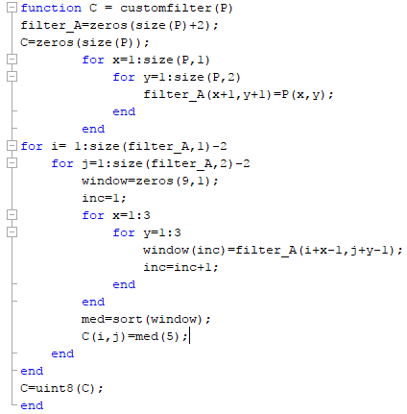

Lowpassfilter.m

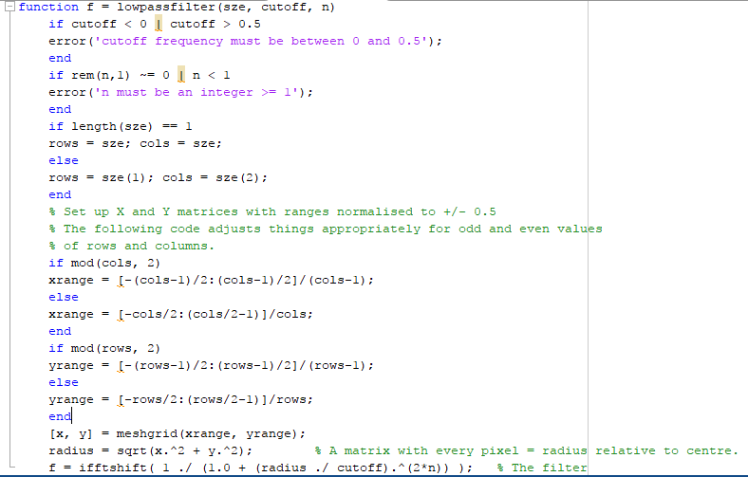

Imshow.m

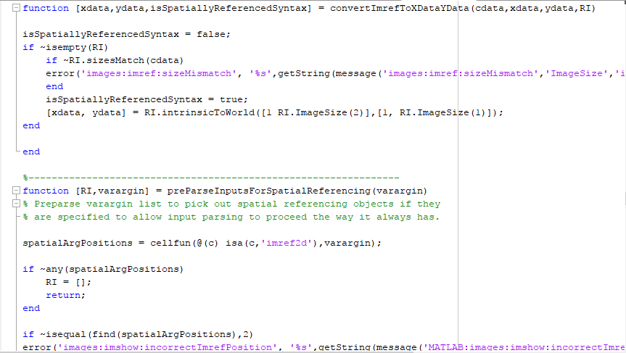

Iffft2.m

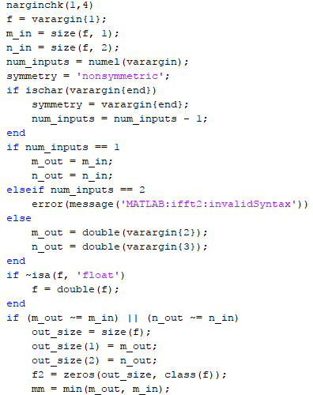

**Manhattan Distance**

The distance between two points measured along axes at right angles. In a plane with p1 at (x1, y1) and p2 at (x2, y2), it is |x1 - x2| + |y1 - y2|.

The distance between two points in a grid based on a strictly horizontal and/or vertical path (that is, along the grid lines), as opposed to the diagonal or "as the crow flies" distance. The Manhattan distance is the simple sum of the horizontal and vertical components, whereas the diagonal distance might be computed by applying the Pythagorean Theorem.

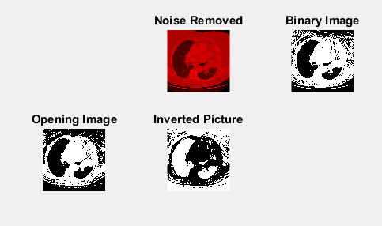

**6. Conclusion and Result**

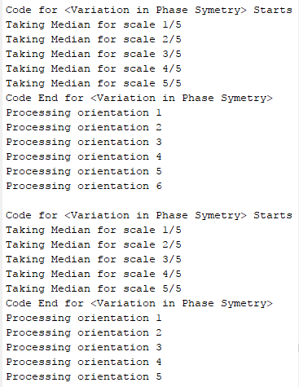

The following is the observed result obtained from the Matlab code that is processed on a sample test image. The system retrieves 3 images that are nearly similar to that of the query image-

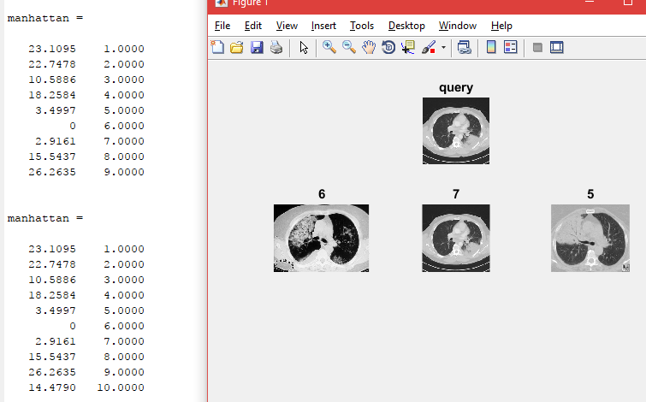

Code snippet

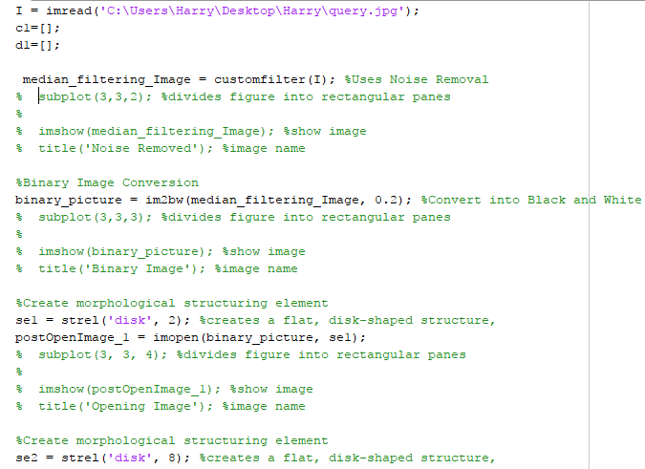

**8. References.**

[1] <https://medlineplus.gov/tuberculosis>.

[2] <https://xlinux.nist.gov/dads/HTML/manhattanDistance.html>

[3] <https://in.mathworks.com/matlabcentral/answers/346524-what-is-gabor-wavelet-transform-in-image-processing>

[4] <https://arxiv.org/abs/1602.03308>

[5] <http://ieeexplore.ieee.org/document/4673555/>